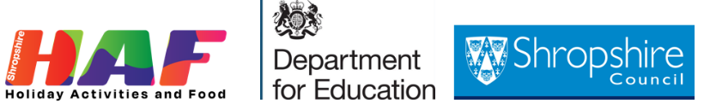

**Shropshire HAF (Holiday Activities & Food) Programme Privacy Notice**

***For parents and carers booking children and young people onto Shropshire HAF Activity***

This privacy notice relates only to the sharing and handling of personal contact details and data between parents/carers boking onto HAF holiday clubs, organisations running HAF holiday clubs and Shropshire Council. It should be read in conjunction with the privacy notice of the organisation who are running a HAF holiday club and the council’s general privacy notice: [Your privacy | Shropshire Council](https://www.shropshire.gov.uk/privacy/your-privacy/)

For the purpose of data protection legislation, the organisation running the holiday club is a data controller of personal data collected and Shropshire Council is a data controller of personal data provided to us by the organisations running the holiday club as part of DfE reporting and grant requirements.

The Holiday Activities and Food (HAF) programme is funded by the Department for Education (DfE).

**As part of your HAF booking at a holiday club, you will be asked to agree at the booking stage for information (“data”) relating to you and your child/ren being processed for the reasons set out below.**

**How do we collect information from you? -** The organisation running the HAF holiday club collect information from you when you book your child/ren onto the HAF holiday club. This data is shared with the Shropshire Council HAF team as part of eligibility checks and monitoring and evaluation

**How we will use your information?** - We collect the minimum personal information necessary from the organisation running the HAF holiday club.

**The information will be used to:**

* carry out eligibility checks, by the FSM (Free School Meal) team at Shropshire Council, to ensure children and young people accessing the programme are eligible for HAF
* help Shropshire Council to co-ordinate the free holiday activities programme effectively across the county
* monitor and evaluation the programme
* provide information to the Department for Education who fund this programme and Childcare Works the organisation appointed by the DfE to manage the programme nationally
* send you information and opportunities we think you will find useful

The information will be securely shared and will be fully anonymised when shared with the DfE and Childcare Works.

We will not sell or rent your information to third parties. We will not share your information with third parties for marketing purposes.

**The personal data collected at this stage will include:**

* Your child/rens name/s
* Your child/rens date of birth
* Postcode
* Name of school/s your child/ren attend
* If your child/ren has SEND (Special educational needs and disabilities)

**How Long will we keep your information for?** All data will be deleted by Shropshire Council at the end of 2025, once reporting to the DfE on the 2024 HAF programme has been completed.

**Deleting your information -** Please follow the HAF holiday clubs’ guidelines direct on deleting your data from their application.

**Consent -** By making the booking with the holiday club, you give consent for you and your child/ren’s personal information to be shared with Shropshire Council and HAF project partners as stated above.

**For more information on this privacy notice please go to** [Your privacy | Shropshire Council](https://www.shropshire.gov.uk/privacy/your-privacy/)

**For more information about HAF please go to** [HAF holiday clubs | Shropshire Council](https://next.shropshire.gov.uk/education-and-learning/holiday-activities-and-food-programme-haf/haf-holiday-clubs/?month=&location=)